Catch-22

A Catch-22 is a paradoxical situation where you are trapped by contradictory rules or conditions, making it impossible to escape or resolve the problem. The term originates from Joseph Heller's novel “Catch-22”, published in 1961, which satirizes bureaucracy and the absurdity of war. In the novel, “Catch-22” describes a regulation which states that a pilot can be grounded for being insane, but if you request to be grounded (because of dangerous missions), it means that you are sane, since only a rational person would avoid danger. Therefore, the pilot cannot escape flying the missions, unless he is deemed to be insane by another person. This is a “no-win” situation. It can be represented by the flowchart below:
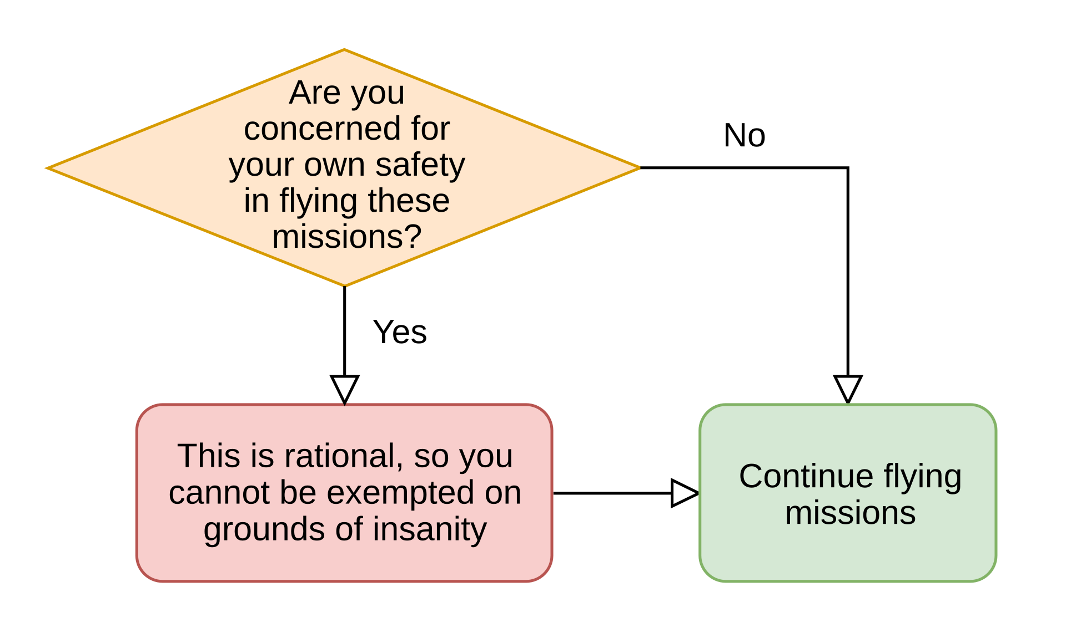

“Catch-22” is also the name of a 1970 American satirical comedy war film adapted from Joseph Heller’s novel.

Modern Usage
In everyday language, the words “Catch-22” means “a frustrating, circular predicament” – a dilemma which has no good solution. Here are some examples:

1. Job application
You need work experience to get a job, but you need a job to get work experience.

2. Bank loan
You can’t get a bank loan if you don’t have a credit history, but you can’t get a credit history without a loan.

3. Customers in a restaurant
A restaurant can’t attract customers if it is empty, and customers don’t want to enter a restaurant if it is empty.

Notes:

1. The number 22 has no important significance, it was chosen for its “euphony” (how the words sound).

2. The phrase “catch-22” does not translate easily to other languages, but in Portuguese it means “beco sem saída” or “impasse”.

